Original Article
Effect of papaya (Carica papaya L) leaves flour on the growth performance and immunity parameters of whiteleg shrimp (Litopenaeus vannamei) challenged with Vibrio parahaemolyticus

Andre Rachmat Scabra*, Rangga Idris Affandi, Muhammad Sudirman

Aquaculture Study Program, Department of Fisheries and Marine Science, Faculty of Agriculture, University of Mataram, Indonesia.

Introduction
Whiteleg shrimp (Litopenaeus vannamei), of high economic value, is cultivated in Indonesia. High demand from overseas markets, expected to increase, and sufficient resources available in Indonesia provide significant development opportunities. In 2022, the United States remained the primary export destination for Indonesian whiteleg shrimp, with a market value of USD 1.42 billion, accounting for 66.0%. According to statistics from the Directorate General of Aquaculture (2024), whiteleg shrimp production in Indonesia reached 1,134,017 tons, increasing at an average annual rate of 5.91%. It is a favorite among marine aquaculture farmers due to its several advantages, including a high feed-to-appetite ratio, strong pathogen resistance, and greater tolerance of adverse environmental conditions. Whiteleg shrimp also offer benefits such as faster growth, a high survival rate, relatively high stocking density, and a relatively short maintenance period of around 90-100 days per cycle (Khumaidi et al., 2022).
One of the main challenges in Whiteleg shrimp cultivation is the high disease-related mortality. The most common disease affecting shrimp is Vibrio parahaemolyticus infection. According to Kusmarwati et al. (2017), V. parahaemolyticus is a naturally occurring bacterium in brackish and coastal waters that is pathogenic to shrimp and humans. This bacterium is naturally found in aquatic environments. One approach to preventing infectious diseases is to enhance the immune response by administering immunostimulants. Immunostimulants are compounds that enhance immune function, particularly by activating immune cells that play a crucial role in the body's defense against pathogens. One natural immunostimulant ingredient commonly used is papaya (Carica papaya L.) leaf extract.
Papaya leaves contain the enzyme papain, which plays a role in protein breakdown (proteolytic activity), and the alkaloid carpaine, which has antibacterial activity. Furthermore, the flavonoids present in papaya leaves exhibit antibacterial and antioxidant properties that may enhance shrimp immune function (Wicaksono et al., 2020). The use of papaya leaf flour to boost shrimp immune systems has not been widely practiced. Therefore, this work aimed to investigate the effect of papaya (Carica papaya L.) leaf flour on the growth performance and challenge of Whiteleg Shrimp with Vibrio parahaemolyticus.

Materials and Methods
This research was conducted over 56 days, from January to March 2025, at the Fish Production and Reproduction Laboratory and the Fish Health Laboratory, Aquaculture Study Program, Faculty of Agriculture, University of Mataram. This study employed a Completely Randomized Design (CRD) with five treatments and three replications, yielding 15 experimental units. The levels of papaya leaf flour added to the feed were based on the preliminary test as follows: P1 (Control +): Feed without Papaya Leaf Flour + Bacterial Infection; P2 (Control -): Feed without Papaya Leaf Flour + 0.9% NaCl; P3: Feed + 2% Papaya Leaf Flour + Bacterial Infection; P4: Feed + 4% Papaya Leaf Flour + Bacterial Infection, and P5: Feed + 6% Papaya Leaf Flour + Bacterial Infection
Preparation of containers and maintenance media: The rearing tanks were 45-liter containers measuring 40x30x28 cm, with 15 units. The containers were first brushed using detergent, then rinsed, and then dried for 24 hours. They were then placed in a completely randomized design, prepared, and labeled according to the treatment assignment. Next, the containers were filled with 25 liters of seawater, each equipped with an aeration system to oxygenate the water and a lid to prevent the shrimp from escaping.
Test animal preparation: The test animals used in this study were PL-10 whiteleg shrimp obtained from PT company, Anugrah Agung Sumbawa (AAS) in Luk Village, Rhee District, Sumbawa Besar Regency, Indonesia. The shrimp were acclimated for 13 days to adapt to their new environment. After PL-23, the shrimp were placed in containers at a stocking density of 25 per container (Scabra et al., 2025).
Feed preparation: The study feed was a commercial feed supplemented with papaya leaf flour at 2, 4, and 6% by weight, based on preliminary testing. Papaya leaf flour was prepared by weighing 500 grams of papaya leaves to produce 100 grams of flour. Then, they were washed thoroughly and dried in an oven at 60°C for 24 hours. The dried leaves were then blended into a smooth powder. The powder was then sieved through an 80-mesh sieve to obtain a finer powder. The feed and flour were then mixed thoroughly. Then, 3.5 ml of egg white was added per 100 grams of feed as a binder, mixed with 10 ml of water, and stirred thoroughly. The mixture was then placed in an oven for 4 hours at 40-50°C. The filtering process resulted in a finer powder.
Feeding and water changes: Feeding was ad libitum, with shrimp fed until satiation at specified times. The shrimp are reared for 56 days. Feeding frequency is four times daily at 7.30, 10.30, 14.30, and 17.30 local time. The water source was Alang-Alang Beach in Senggigi, West Lombok. Water quality management was performed by siphoning 10% of the container volume each morning.
Test Bacteria Preparation: The bacteria used were precultured V. parahaemolyticus from the Fish Health Laboratory of the Aquaculture study program and were rejuvenated before injection into the shrimp. The rejuvenation process was carried out in TSB (Trypticase Soy Broth) media. The bacterial isolate was collected using a loop needle and then serially diluted in a 10⁶ dilution Eppendorf tube. The final dilution was then added to liquid TSB and incubated at room temperature for 24 hours. Afterward, 100 µl was withdrawn using a syringe and injected into the shrimps.
Challenge test: The challenge test aimed to determine the effect of papaya leaf flour on shrimp infected with V. parahaemolyticus. The challenge test was conducted on day 45 of culture. The shrimp were then cultured for 10 days until the 56th day. The treated shrimp were fasted for one day. Subsequently, all treatments except P2 (negative control) were infected with bacteria at a density of 10⁶ CFU/ml. The infection method used was intramuscular injection, with 100 μL per shrimp injected into the dorsal region between the second and third segments.
Hemolymph collection: Hemolymph is collected to analyze parameters related to shrimp health and immune response. These parameters include Total Hemocyte Count (THC), Differential Hemocyte Count (DHC), Phagocytic activity, and blood glucose. Shrimp blood samples were obtained 10 days after the challenge test. 0.1 ml of hemolymph was collected from the base of the fifth walking leg using a syringe containing 0.2 ml of anticoagulant. The anticoagulant was prepared as a mixture of 0.44 g of trisodium citrate, 0.99 g of sodium chloride, 0.19 g of EDTA, and 50 ml of distilled water. The hemolymph and anticoagulant mixture were homogenized for 5 minutes.
Research parameters
Survival rate (SR): the proportion of shrimp that survive (Supono et al., 2021). It is calculated using the formula of SR = (Nt/N_{o}) x 100%, where SR = Survival rate (%), No = Number of shrimps at the beginning of the study, and Nt = Number of live shrimps at the end of the study.
Specific weight growth rate: The specific weight growth rate was calculated to determine the average growth of whiteleg shrimp from the beginning to the end of the study. The specific growth rate can be calculated using the formula (Dahlan et al., 2019) of SWGR = (LnWt-LnWo)/t x 100%, where, SWGR = Specific weight growth rate (%), Wt = Average shrimp weight at the end of cultivation (g), W₀ = Average shrimp weight at the beginning of cultivation (g), and T = Duration of cultivation (days).
Specific length growth rate: The specific length growth rate can be calculated using the formula (Supono et al., 2021) of SLGR = (LnWt-LnWo)/T x 100%, $w$here, SLGR= Specific length growth rate (%/day), Wt = Shrimp length at the end of cultivation (cm), W0 = Shrimp length at the beginning of cultivation (cm), and T = Maintenance time (days).
Feed conversion ratio: FCR is the ratio between the amount of feed given and the meat produced. The feed conversion ratio is calculated using the Scabra et al. (2021) as follows: FCR = F/((Wt+D)-W0), where, FCR: Feed conversion ratio, Wt = Final shrimp weight (g), W0 = Initial shrimp weight (g), F = Feed Given (g), and D = Weight of Shrimp Dead during Maintenance (g).
Blood glucose: A primary indicator of stress in shrimp and fish; in our study, it was measured using a glucose meter. In shrimp, a glucose concentration exceeding 150 mg/dL indicates that the shrimp requires more energy, especially during moulting or to maintain physiological stability (homeostasis). High glucose levels suggest that the shrimp are in a condition that requires additional energy. Drastic environmental changes can also induce stress in shrimp, as indicated by increased hemolymph glucose levels (Widodo et al., 2011).
Phagocytic activity: PA was assessed by adding 25 µL of Staphylococcus sp. (107 CFU/mL) to 0.1 mL of hemoglobin, incubating for 20 minutes. Next, 10 µl of the mixture was taken, prepared as a smear, fixed in methanol for 5-10 minutes, and then dried. The mixture was then soaked in Giemsa stain for 15-20 minutes, rinsed with distilled water until the color faded, and then rinsed again with distilled water. The smear was then observed under a microscope at 40x magnification (Jannah et al., 2018).
PA = (Number of cells that perform phagocytosis)/(Number of phagocytic cells) x 100%.
Water quality: Water quality parameters monitored during the study included DO, temperature, pH, salinity, and ammonia (NH₃⁺). Checks were conducted three times during the study: at the beginning, in the middle, and at the end.
Data analysis: The results were analyzed using SPSS (Version 16.0). An ANOVA test was performed at the 95% confidence level (P<0.05). If the results were significantly different, Duncan's test was used for further testing.

Results
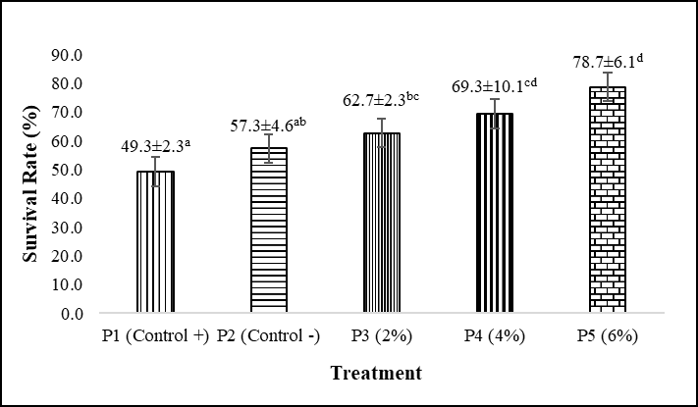
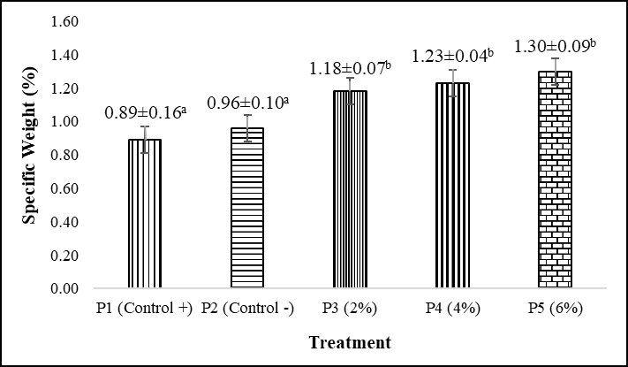
Survival Rate (SR): The results showed that the addition of papaya leaf flour to enhance the immune system of whiteleg shrimp resulted in a significant difference (P<0.05) in the survival rate of whiteleg shrimp. Therefore, further testing was carried out using Duncan's test. The results of the Duncan test showed that treatment P1 (positive control) differed significantly from P3 (2% dose), P4 (4% dose), and P5 (6% dose), but did not differ significantly from P2 (negative control). The highest value was observed in treatment P5 (6% dose; 78.7%), and the lowest in treatment P1 (positive control; 49.3%) (Fig. 1).
Figure 1. Effect of papaya leaves flour supplementation on survival rate in Whiteleg shrimp challenged with Vibrio parahaemolyticus.

Figure 2. Effect of papaya leaves flour supplementation on specific weight growth rate in Whiteleg shrimp challenged with Vibrio parahaemolyticus.

Specific Weight Growth Rate: The results showed that the addition of papaya leaf meal to the feed to boost the immunity of whiteleg shrimp resulted in a significant difference (P<0.05) in the specific weight of whiteleg shrimp. Therefore, further testing using Duncan's test showed that treatment P1 (positive control) differed significantly from P3 (2% dose), P4 (4% dose), and P5 (6% dose), but not from P2 (negative control). The highest value was observed in treatment P5 (6% dose; 1.30%/day), and the lowest in treatment P1 (positive control; 0.89%/day) (Fig. 2).
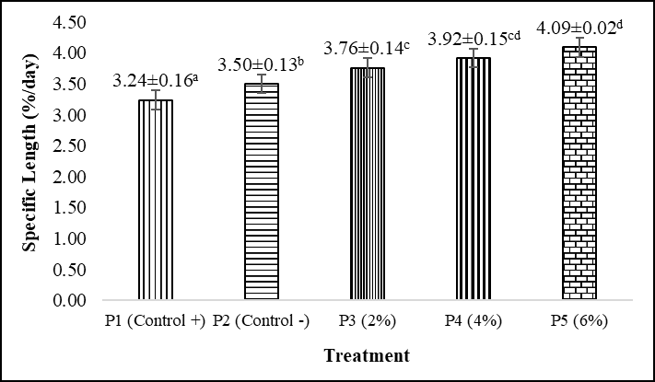
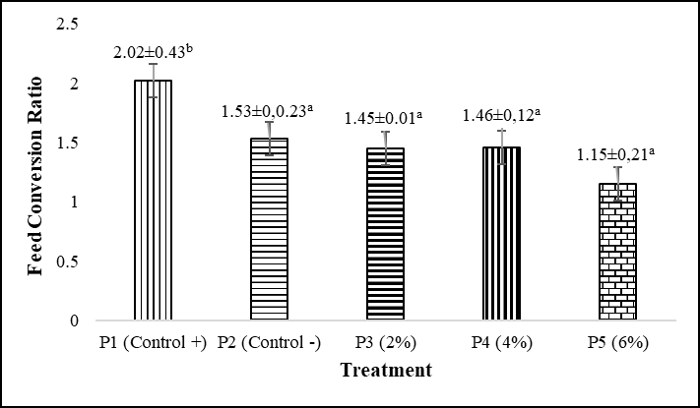
Specific length growth rate: The results revealed that adding papaya leaf flour to the feed to boost whiteleg shrimp immunity resulted in a significant difference (P<0.05) in specific growth rate. The treatment P1 (positive control) showed a significant difference compared to P2 (negative control), P3 (2% dose), P4 (4% dose), and P5 (6% dose). The highest value was observed in treatment P5 (6% dose; 4.09%/day), and the lowest in P1 (positive control; 3.24%/day) (Fig. 3).
Figure 4. Effect of papaya leaves flour supplementation on FCR in Whiteleg shrimp challenged with Vibrio parahaemolyticus.

Figure 3. Effect of papaya leaves flour supplementation on specific length growth rate in Whiteleg shrimp challenged with Vibrio parahaemolyticus.

Feed conversion ratio: The results showed that adding papaya leaf Flour to feed to improve whiteleg shrimp immunity significantly (P<0.05) affected the feed conversion ratio. The treatment P1 (positive control) differed significantly from P2 (negative control), P3 (2% dose), P4 (4% dose), and P5 (6% dose). The highest value was observed in treatment P1 (positive control; 2.02), and the lowest in treatment P5 (6% dose; 1.15) (Fig. 4).
Blood glucose: Adding papaya leaf flour to the feed to boost whiteleg shrimp immunity did not significantly affect blood glucose levels (P>0.05). Treatment P1 (positive control) showed no significant difference compared to P2 (positive control), P3 (2% dose), P4 (4% dose), and P5 (6% dose). The highest value was observed in treatment P5 (6% dose; 67 mg/dL), and the lowest in treatment P2 (negative control; 36 mg/dL) (Fig. 5).
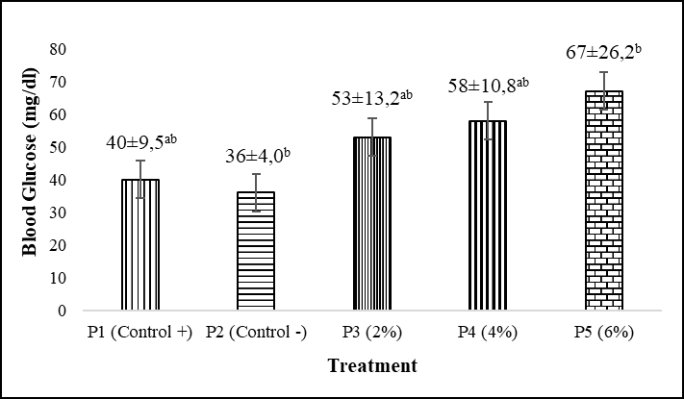
Phagocytic activity: Adding papaya leaf flour to the feed to boost whiteleg shrimp immunity resulted in a significant increase (P<0.05) in phagocytic activity. Therefore, treatment P1 (positive control) showed a significant difference of 67% compared to P4 (4% dose) and P5 (6% dose) at 70%. However, it was not significantly different from P2 (negative control) at 52% and P3 (2% dose) at 61%. The highest value was observed in treatment P5 (6% dose; 70%), and the lowest in treatment P1 (positive control; 51%) (Fig. 6).
Figure 5. Effect of papaya leaves flour supplementation on blood glucose in Whiteleg shrimp challenged with Vibrio parahaemolyticus.

Parameter | Range | References
Dissolved Oxygen  Temperature (℃)  Acidity (pH) | 5.3-7  28.6-29.7  7.9-8.3 | 3.5-7.5 mg/L (Makmur et al., 2018)  28-31℃ (Arsad et al., 2017)  7.5-8.5 (Purnamasari et al., 2017)
Salinity (ppt)  Ammonia (mg/L) | 34-35  0.05-0.08 | 30-35 (ppt) (Supriatna et al., 2020)  <0.10 mg/L (Ismail et al., 2021)

Table 1. The results of the water quality measurement during the experiment.
Water quality: Water quality parameters in the media were measured during the study to determine the suitability of the media for rearing whiteleg shrimp (Table 1).

Discussions
Survival rate (SR): Based on the results, survival rates ranged from 49.3 to 78.7%. According to Scabra et al. (2024), shrimp survival rates are categorized as good (>70%), moderate (50-60%), or low (<50%). According to the results, the highest survival rate occurred in treatment P5. This high value in P5 is attributed to bioactive compounds in papaya leaves, such as flavonoids and phenolics, which act as antioxidants, protecting cells from oxidative stress induced by pathogen infection. Furthermore, the enzyme papain and other proteolytic compounds aid protein digestion, making shrimp metabolism more efficient. The alkaloids and saponins in the leaves have antibacterial properties, as noted by Muahiddah and Diamahesa (2023), who reported that using papaya leaves as a natural immunostimulant increases the non-specific immune response of shrimp, thereby contributing to increased SR. The lowest survival rate was observed in P1; this low value is attributed to the absence of papaya leaf flour in the feed, which resulted in poor shrimp growth. This is consistent with the results of Wicaksono et al. (2020), who reported increased shrimp survival with the addition of papaya leaf extract.
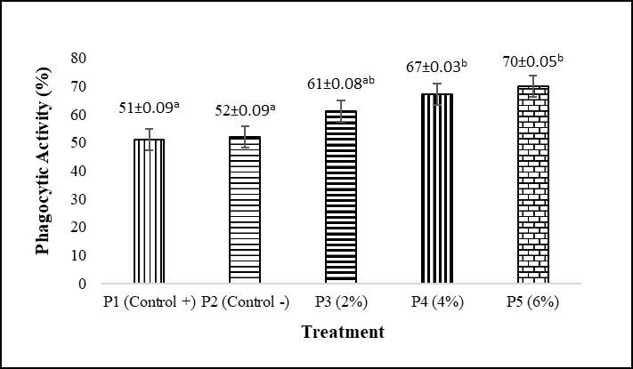
Specific weight growth rate: the percentage rate of change in weight per day (%/day). Based on our results, the highest value was observed in treatment P5 at 1.30%/day, while the lowest was in treatment P1 at 0.89%/day, within a range considered good. This is consistent with research by Dahlan et al. (2019), which reported weight growth rates ranging from 0.76%/day to 1.29%/day. The high specific weight growth rate in P5 can be due to the bioactive compounds in papaya leaves, such as the proteolytic enzyme (papain), which can increase the efficiency of protein utilization from feed. Papain breaks down protein into more easily absorbed peptides and amino acids, thereby improving nutrient absorption and supporting faster growth (Mapparimeng, 2019). The lowest specific growth rate was observed in P1; this low value is attributed to the absence of papaya leaf powder in the feed, which resulted in poor shrimp growth. This is supported by Setyono et al. (2019), who reported that shrimp fed without additional immunostimulants had a lower growth rate and lower body resistance than those fed immunoprotective ingredients. This is consistent with the results of Mubaraq et al. (2021) on catfish (Clarias sp.), which reported the highest specific growth rate in the treatment containing papaya leaf powder.
Figure 5. Effect of papaya leaves flour supplementation on phagocytosis activity in Whiteleg shrimp challenged with Vibrio parahaemolyticus.

Specific length growth rate: In the current study, the highest value was observed in p5 at 4.09%/day, whereas the lowest was in p1 at 3.24%/day. The high specific length growth rate was found in p5. This can be due to the addition of papaya leaf flour to the feed. According to Ahmad (1991), as cited in Scabra et al. (2021), crustacean growth is a gradual process of increasing length and weight, heavily influenced by molting (Scabra et al., 2023). Moulting increases the length and weight of whiteleg shrimp. The lowest specific length growth value was observed in p1; this low value may be due to the absence of papaya leaf powder in the feed, which could have impaired shrimp growth. This is in line with the results of Mubaraq et al. (2021) on catfish (Clarias sp.).
Feed conversion ratio: Based on the results, treatment P1 had the highest FCR (2.02), and P5 had the lowest (1.15). This aligns with research by Nurhasanah et al. (2021), which found FCR values ranged from 0.89 to 1.85. The low FCR value is attributed to the papain enzyme content in papaya leaves, which degrades feed protein, thereby facilitating nutrient absorption by the shrimp. Maximized nutrient absorption contributes to accelerated growth and more effective feed utilization. This indicates that shrimp can utilize feed very efficiently, which directly affects optimal growth. This suggests that the feed provided can be optimally converted into shrimp body biomass (Scabra et al., 2021). The highest FCR value in P1 may be due to the absence of papaya leaf powder in the feed, resulting in poor shrimp growth. This is in line with Mubaraq et al. (2021) on catfish (Clarias sp.).
Blood glucose: Shrimp blood glucose levels are a physiological indicator of stress levels during cultivation. Poor environmental conditions often cause elevated glucose levels. Our results have ranged from 36 to 67 mg/dl. Blood glucose testing can be used to assess shrimp stress levels; high glucose levels indicate stress, whereas low or normal glucose levels indicate good condition (Widodo et al., 2011). Hemolymph glucose concentrations exceeding 150 mg/dl indicate that shrimp require increased energy, particularly during molting and efforts to maintain homeostasis, as evidenced by elevated hemolymph glucose levels (Widodo et al., 2011).
Phagocytic activity: Phagocytosis is a nonspecific defense mechanism that protects against disease. Increased phagocytic activity indicates that the organism can produce more phagocytic cells in its hemocytes, so that when exposed to pathogenic microorganisms, the hemocytes are ready to phagocytize (Serina et al., 2022). Based on our results, the highest value was 70% in P5, and the lowest was 51% in P1. This is consistent with the findings of Abdi et al. (2022), who reported that phagocytosis activity ranged from 47.3% to 70.41%. The increase in phagocytic activity observed across treatments, resulting from the addition of papaya leaf flour to the feed at different doses, affected the immune system of whiteleg shrimp. The addition of papaya leaf flour to the feed at different doses contains immunostimulants because the flour contains antibacterial compounds that can stimulate or enhance the shrimp's immune system by stimulating increased phagocytosis activity. Immunostimulants can enhance immune function by directly modulating phagocytic cell activity, thereby activating the immune system (Monica et al., 2017).
Water quality: Shrimp are aquatic animals whose entire life, health, and growth depend on the quality of the water in which they live (Makmur et al., 2018). The water quality measurements, including DO, temperature, pH, salinity, and ammonia, were within optimal ranges in the current study. DO is a fundamental requirement for sustaining life, and water provides oxygen that supports the survival of aquatic biota. Based on the current study results, DO values ranged from 6.8 to 7.0 mg/L. This aligns with Makmur et al. (2018) as the optimal Do for whiteleg shrimp (3.5 -7.5 mg/L). Temperature is a crucial environmental factor for shrimp farming because it can affect metabolism, growth, immune response, and survival. The values in the current study were 28.6-29.7°C, which are considered optimal for whiteleg shrimp (Arsad et al., 2017).
The pH values in our study ranged from 7.9 to 8.3, which is still considered normal (Purnamasari et al., 2017). Salinity affects aquatic organisms by controlling the balance of water and ions between the body and its environment. Excessive salinity can affect fish weight growth, resulting in suboptimal growth. However, salinity appropriate to a fish's osmoregulatory capabilities can enhance growth. The values recorded during the study ranged from 34 to 35 ppt, which is considered optimal (Supriatna et al., 2020). Ammonia is a water-quality parameter observed in aquatic environments, originating from the decomposition of organic matter containing high levels of nitrogen (protein) from feed residues. Ammonia levels in the current work ranged from 0.05 to 0.09 mg/L (Ismail et al., 2021).

Conclusion
Based on the results, it can be concluded that the addition of papaya leaf flour in feed significantly affected the survival rate, specific weight growth rate, specific length growth rate, feed conversion ratio, and phagocytosis activity of whiteleg shrimp challenged with V. parahaemolyticus. The best treatment was P5, which showed SR of 78.7%, SWGR of 1.30%, SLGRe of 4.09%/day, FCR of 2.02, and Phagocytosis activity of 70%.

Acknowledgements
The author would like to thank his supervisor for the assistance, advice, guidance, and support provided during the research process; the study program for providing facilities and infrastructure; and all parties who assisted with this research.
References
Abdi R., Setyowati D.N., Mukhlis A. (2022). The effect of adding jeruju leaf extract (Acanthus ilicifolius) at different doses to feed on the survival of whiteleg shrimp (Litopenaeus vannamei) infected with Vibrio parahaemolyticus. Fisheries Journal, 12(1): 33-44.
Arsad S., Afandy A., Purwadhi A.P., Maya V.B., Saputra D.K., Buwono N.R. (2017). Study of whiteleg shrimp culture (Litopenaeus vannamei) in different rearing systems. Scientific Journal of Fisheries and Marine Sciences, 9(1): 1-10.
Dahlan J., Hamzah M., Kurnia A. (2019). Growth of whiteleg shrimp (Litopenaeus vannamei) cultured in a biofloc system with the addition of probiotics. JSIPi (Journal of Fishery Science and Innovation), 1(2): 19-27.
Directorate General of Aquaculture. (2024). Performance report of the directorate general of aquaculture 2024. Ministry of Maritime Affairs and Fisheries, Republic of Indonesia.
Ismail I., Scabra A.R., Marzuki M. (2021). The effect of phosphorus addition to cultivation media on the growth rate of whiteleg shrimp (Litopenaeus vannamei) fry at 0 ppt salinity. Indonesian Journal of Aquaculture Medium, 1(2): 113-124.
Jannah M., Junaidi M., Setyowati D.N., Azhar F. (2018). The effect of Lactobacillus sp. at different doses on the immune system of whiteleg shrimp (Litopenaeus vannamei) infected with Vibrio parahaemolyticus. Indonesian Journal of Marine Science and Technology, 11(2): 140-150.
Khumaidi A., Muqsith A., Wafi A., Jasila I., Hikam T. (2022). Technical study of intensive whiteleg shrimp (Litopenaeus vannamei) rearing in BPBAP Situbondo shrimp ponds. Pantura Fisheries Journal, 5(2): 195-205.
Kusmarwati A., Yenni Y., Indriati N. (2017). Antibiotic resistance in Vibrio parahaemolyticus from whiteleg shrimp from the north coast of Java for the export market. Journal of Postharvest and Marine and Fisheries Biotechnology, 12(2): 91-106.
Makmur, Suwoyo H.S., Fahrur M., Syah R. (2018). The effect of the number of aeration points on the cultivation of whiteleg shrimp, Litopenaeus vannamei. Journal of Tropical Marine Science and Technology, 10(3): 727-738.
Mapparimeng M. (2019). The effect of adding papaya leaf extract (Carica papaya) to tilapia (Oreochromis niloticus) feed. Agrominansia, 3(2): 148-158.
Monica M., Wardiyanto, Susanti O. (2017). Non-specific white shrimp (Litopenaeus vannamei): A study of the potential of papaya leaf extract (Carica papaya L.) for non-specific against non specific immunity of vannamei shrimp. Scientific Journal of Fisheries and Marine Sciences, 9(2): 127-133.
Muahiddah N., Diamahesa W.A. (2023). The use of immunostimulants from papaya leaves to treat disease and increase non-specific immunity in fish and shrimp. Journal of Fish Health, 3(1): 19-24.
Mubaraq M.B., Marzuki M., Azhar F. (2021). The effect of adding papaya leaf powder (Carica papaya) to feed to increase the growth of catfish (Clarias sp.). Journal of Aquaculture Science, 6(2): 83-92.
Purnamasari I., Purnama D., Utami M.A.F. (2017). Growth of whiteleg shrimp (Litopenaeus vannamei) in intensive ponds. Enggano Journal, 2(1): 58-67.
Scabra A.R., Junaidi M., Hafizi A. (2024). Growth of vannamei shrimp (Litopenaeus vannamei) in rearing media with different salinities. Journal of Tropical Biology, 24(2): 26-36.
Scabra A.R., Marzuki M., Cokrowati N., Setyono B.D.H., Mulyani L.F. (2021). Increasing calcium solubility through the addition of Terminalia catappa ketapang leaves to freshwater media for vannamei shrimp (Litopenaeus vannamei). Fisheries Journal, 11(1): 35-49.
Scabra A.R., Marzuki M., Rizaldi A. (2023). Effect of calcium hydroxide (Ca(OH)₂) and magnesium sulfate (MgSO₄) on vannamei shrimp (Litopenaeus vannamei) cultivation in freshwater media. Acta Aquatica: Aquatic Sciences Journal, 10(1): 77-87.
Scabra A.R., Azhar F., Alim S., Nurliah, Nurussalam W., 2025 Feed supplementation with calcium from shrimp shells in vannamei shrimp (Penaeus vannamei) cultivated in low salinity media. AACL Bioflux, 18(5): 2133-2147.
Serina D., Dahlia D., Ardiansyah A., KS., Unga Mega D.A. (2022). Application of Moringa oleifera Lam. leaf extract in culture media to increase non-specific immunity of whiteleg shrimp larvae (Litopenaeus vannamei, Boone 1931). Proceedings of the National Seminar of the Pangkajene Islands State Agricultural Polytechnic, 3(September): 183-192.
Setyono B.D.H., Azhar F., Paryono P. (2019). Application of biofloc combined with probiotics on the growth performance of whiteleg shrimp (Litopenaeus vannamei). Udayana Veterinary Bulletin, 3: 7-14.
Supono S., Pinem R.T., Harpeni E. (2021). Performance of whiteleg shrimp (Litopenaeus vannamei) (Boone, 1931) reared in a biofloc system with different carbon sources. Jurnal Kelautan: Indonesian Journal of Marine Science and Technology, 14(2): 192-202.
Supriatna S., Mahmudi M., Musa M., Kusriani K. (2020). The relationship between pH and water quality parameters in intensive whiteleg shrimp (Litopenaeus vannamei) ponds. Journal of Fisheries and Marine Research, 4(3): 368-374.
Wicaksono B., Dwinanti S.H., Hadi P. (2020). Controlling the green colony population of Vibrio sp. in whiteleg shrimp (Litopenaeus vannamei) cultivation using papaya leaf extract (Carica papaya L.). Intek Aquakultur, 4(1): 12-23.
Widodo A.F., Pantjara B., Adhiyudanto N.B. (2011). Physiological performance of whiteleg shrimp. Journal of Aquaculture Research, 6: 225-241.

*Correspondence: Andre Rachmat Scabra DOI: https://doi.org/10.22034/ijab.v14i1.2584 E-mail: andrescabra@unram.ac.id

